Pokhara University

Level: Bachelor | Semester – Fall | Year : 2009
Programme: BE |  | Full Marks : 100
Course: Electronic Circuit I |  | Time : 3hrs.

Candidates are required to give their answers in their own words as far as practicable.
The figures in the margin indicate full marks.

Attempt all the questions.

1. | - Why cascading is necessary? Find the gain of n-stage cascaded amplifiers?  - The self bias circuit is given below.  Find out:  - V_{L} / V_{S}  - Repeat part (i) if R_{E} is unbypassed.  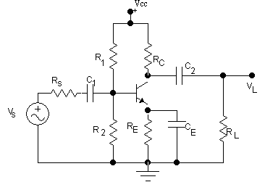  Assume R_{S} = 1.5kΩ, R₁ = 130 KΩ, R₂ = 10 KΩ, R_{C} = 12 KΩ, R_{E} = 1 K Ω, R_{L} = 60KΩ.,  = 100  Vcc= 24v. | 7  8
2. | - What is bandwidth of an amplifier? Explain frequency response of an amplifier. Draw gain versus frequency plot of amplifier.  - Explain class B operation and show this concept is utilized in push-pull amplifier. Find the power conversion efficiency of this operation. What is cross over distortion? | 7  8
3. | - Explain whether stability increases or decreases with negative feedback? Write the main advantages and disadvantages of negative feedback?  - Explain different types of negative feedback topologies with necessary circuit diagrams. | 7  8
4. | - State Barkhausen criterion for oscillation. Explain Wein Bridge oscillator with circuit Diagram. Derive the expression for the frequency of oscillator?  - A Hartley Oscillator is designed with L₁ =3mH and L₂ = 25µH. The capacitor is variable. Determine the range of capacitance values, if the frequency of Oscillation is to vary between 950 KHz to 1050 KHz. | 7  8
5. | - Design an Operational amplifier circuit to produce output V_{O} = V₁-5V₂+ 7V₃ - 20V₄.  - Explain Instrumentation amplifier and its application. | 7  8
6. | - What is basic principle of analog to digital converter? Explain Parallel A/D converter.  - Draw binary weight resistor DAC and explain its operation. | 8  7
7. | Write short notes on (Any Two)  - Transistor series regulator circuit  - L-section and π-section filter.  - SMPS | 5×2

